**LAB ASSIGNMENT #1**

1. **UML Class diagram for the below scenario:**

***Chat application:*** A user can create an account and add friends using their mobile number or email id. User can chat with any individual from his friends list; User can also create groups and invite his friends to join the group. In addition to that, media like images, video, location can be shared with friends and group.

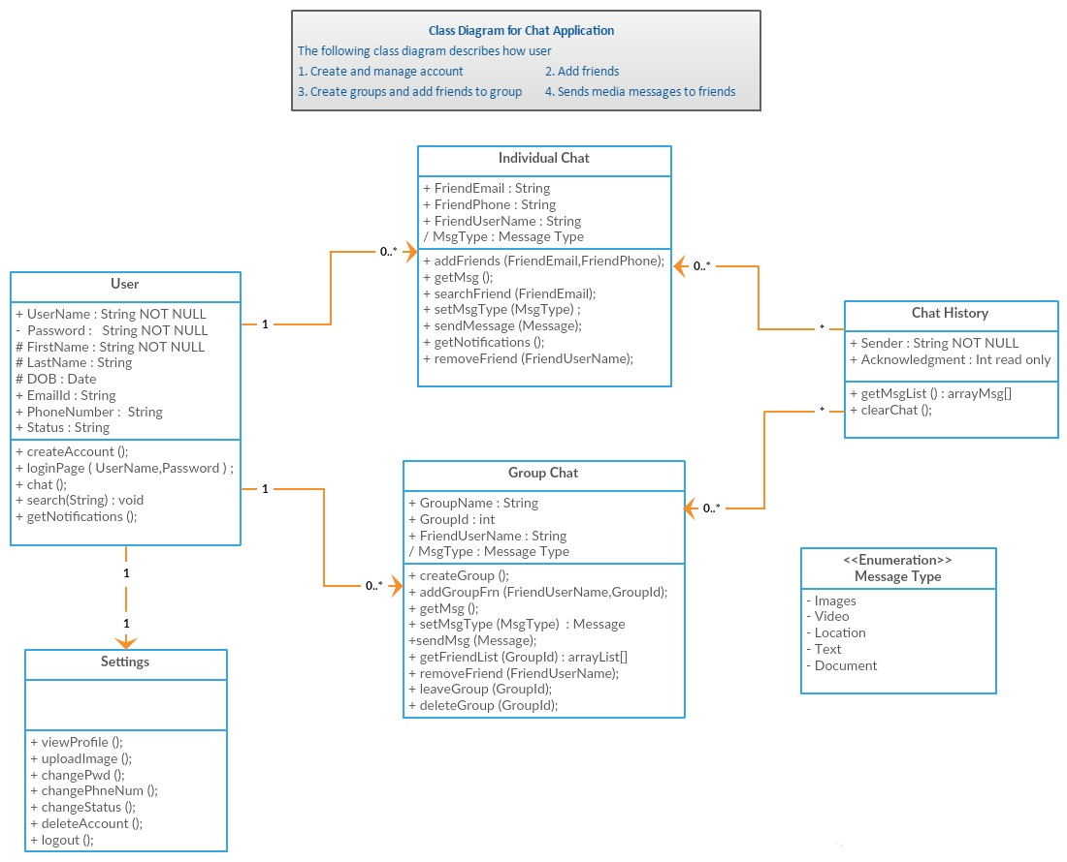

1. **Using ZenHub tool create a board, 3 iterations, at least 5 tasks and show the analytics graph.**

* Under ASE-Lab-Assignments repository 3 milestones are created as Iteration 1, Iteration 2 and Iteration 3.
* Each Milestone is created with Start Date and End Date.
* Under each Milestone 5 tasks are created.
* Each task is assigned to its respective pipelines such as New Issue, Icebox, Backlog, In-Progress, Review, Done and Closed.
* Also each task is given a Story Point i.e. an estimate which is used measure the effort required to implement tasks.

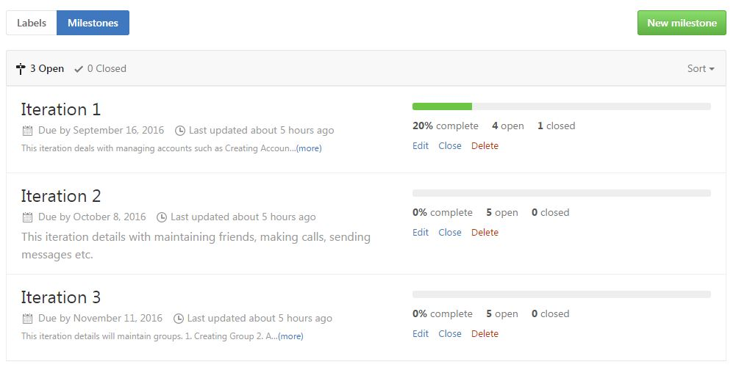

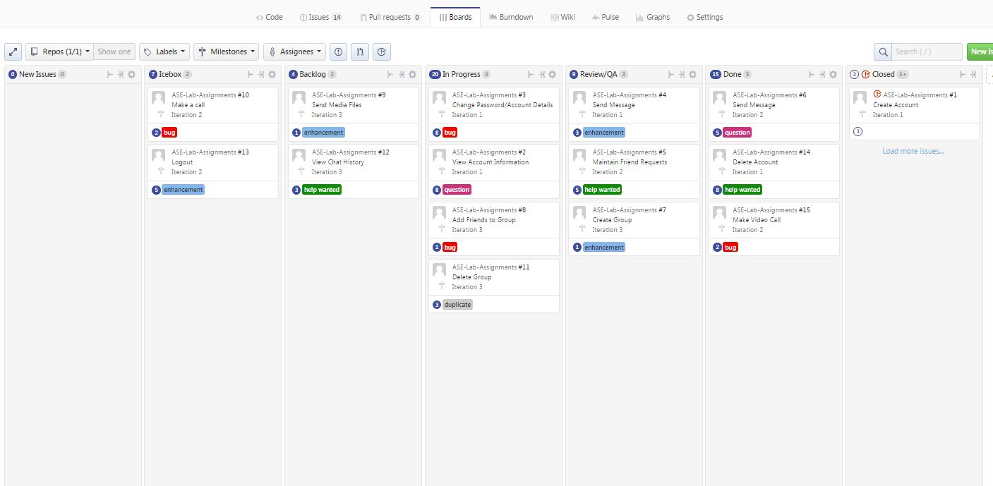

* For each milestone burndown chart is generated which represents the work that is left verses time based on number of issues and its Story Points.

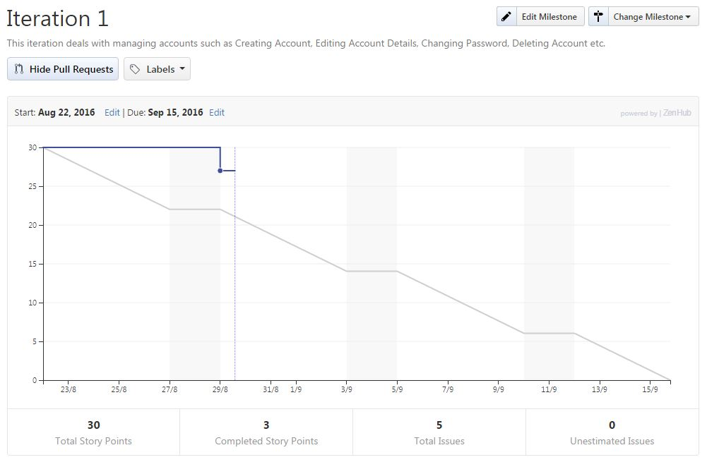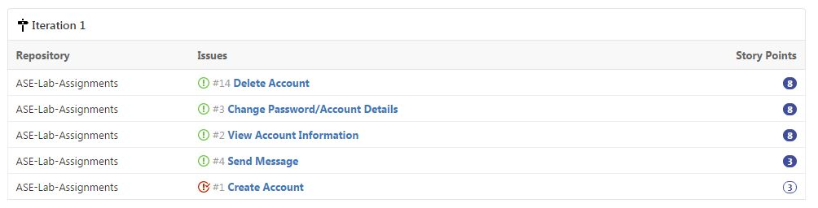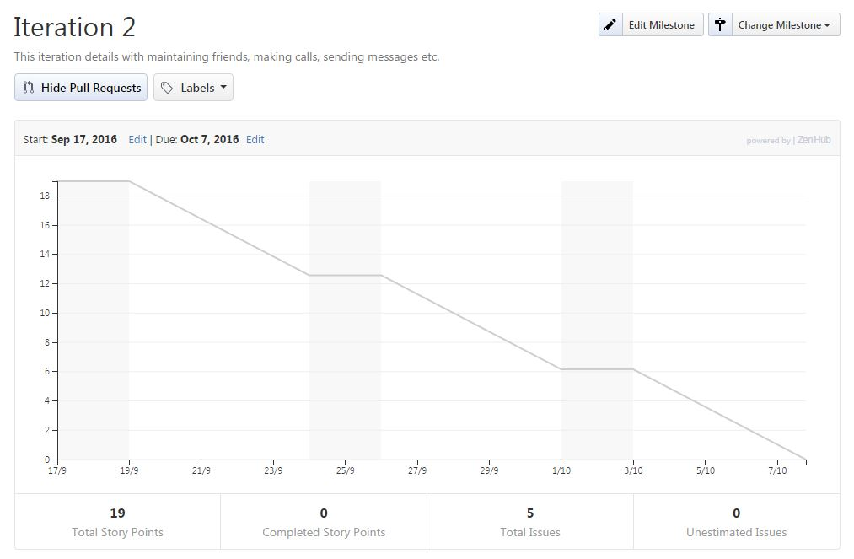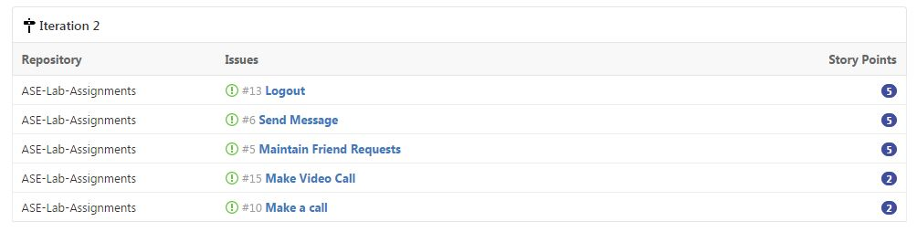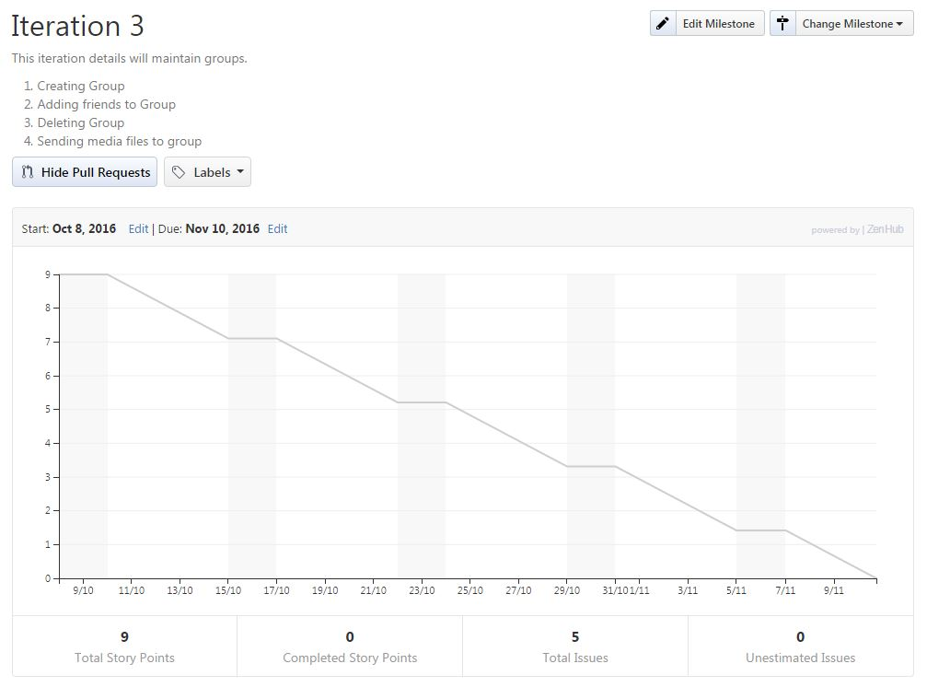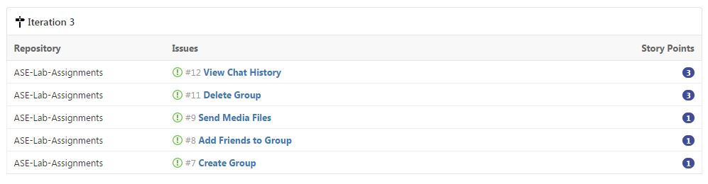

1. **Creating Wiki page through Github**

<https://github.com/cmoulika009/ASE-Lab-Assignments/wiki/ASE-Lab-Assignment-1>

**4) Create GitHub Account. Create a repository in remote Github. Clone it to local machine.**

* New repository ASE-Lab-Assignments is created in remote Github and is cloned to local machine.

